# **Holiday Shenanigans**

**Zoe's avatar**

[Zoe](https://substack.com/@zoeffc)

Dec 13, 2024

Share

Well hello there!

It’s Christmas party season! Or Holiday Party or general End of Year Festivities. Whatever the case may be, like I said last week, December is a wildly different month when it comes to work expectations.

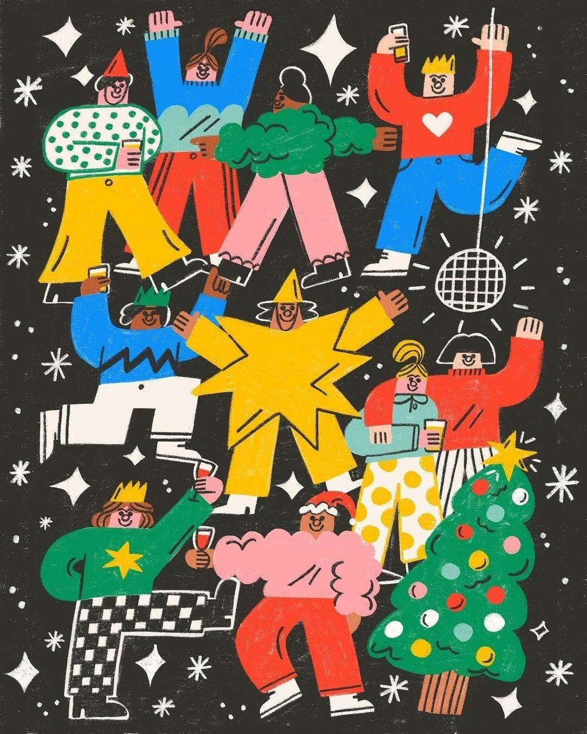

[*@tesssmithroberts*](https://www.instagram.com/p/C1O85D7oPoN/?igsh=MzZmdW5lbnk1NWRv&utm_source=femme-futures.beehiiv.com&utm_medium=referral&utm_campaign=holiday-shenanigans) *on Instagram*

My team is having their holiday party next week and I’ve been privy to a lot of the planning conversations. In those planning conversations, the team tried to fill me in on how holiday parties have looked in the past. Centrally, there was always a White Elephant gift exchange, and there was *always* the opportunity to drink.

This raises the question: how do I drink in a professional setting?

When I asked this question to a couple of my mentors in my field, their initial reaction was that there are different kinds of drinking work events. I work in an industry where we drink with our clients at a number of after-hours events. There is a difference between this drinking and drinking with your team members, (and drinking with your close friends). The advice I received was to set your own rules. One of my mentors’ rules for herself is that she will not drink until the work element of our client-facing event is over. Another person’s rule for themselves was no cocktails, but a glass of wine was fine. Someone else might have a two-cocktail limit at work events. Right now, I don’t drink at all at events like this. Pass me a seltzer with a lime, please!

That being said, I do plan on drinking at my team’s holiday party. I feel like it is a fun way to celebrate a year of challenges and victories. It also feels like an opportunity to bond with my team members and let my guard down a little bit. Before I go into the holiday party and start ordering cocktails, I want to set some boundaries for myself.

Considerations include: (1) I have a pretty low alcohol tolerance, (2) it freaks me out to lose control of what comes out of my mouth, or what I do, especially around people that are not total insiders in my life, (3) I am a person in my twenties and if I get wasted it will be seen as immature, (4) I am pretty risk intolerant, (5) my holiday party is happening at midday, and (5) I have to be able to drive my car home.

These considerations are personal to me and everyone reading this will have different considerations for themselves. However, I think that before we go into these situations, it is wise to at least know what your considerations are. You might notice that some things that you have put on your list are not on mine. For instance, I am not all that susceptible to peer pressure, but you might be. Also, there is no right or wrong way to go about this. We are all adults here. At this point, we know how we feel about alcohol and we know our tolerances. I would strongly advise against getting drunk at work events, with that being said, if you do get drunk, it is not the end of the world. Trust your gut.

Also, if you plan not to drink for any number of reasons, not only is that fine, but that can totally be fun, too. I was at a bar with some friends last week and they had the most spectacular list of mocktails that aren’t just fruit juice with an umbrella. Also, where I am, non-alcoholic beers are taking off and those feel like an ace in my sleeve for events where I want to drink but not get drunk (or even tipsy).

My plan? One drink max - a glass of wine sounds lovely.

I would love to know how or if you all drink in professional settings. I am truthfully feeling my way through this in the dark.

Cheers!

Zoe

Share your thoughts with me by responding to this email or by the Discord!

[Discord](https://discord.gg/SdTNYMAm?utm_source=femme-futures.beehiiv.com&utm_medium=referral&utm_campaign=holiday-shenanigans)

Want to check out the Femme Futures Cooperative archives?

[Archives](https://femme-futures.beehiiv.com/)

**The Femme Futures Cooperative** was founded with a mission to create a community space for young professionals who identify as over-achievers and activists to generate collective success by providing resources and platforms to thrive in challenging workplace environments. Our vision is to contribute to a world where driven individuals are equipped with the tools, guidance, and connections to overcome systemic barriers, fully utilize their talents, and enact positive change in their organizations and communities.